Alexander Baldree

03/11/26

Module 11.1 Discussion Board

CSD340

Topic #87: Not All Mistakes Are Bad
One concept that stood out to me from the reading was #87: Not All Mistakes Are Bad. This topic explains that mistakes are not always negative because they can help people learn and improve systems. In many cases, mistakes reveal problems that designers may not have noticed otherwise. Instead of viewing mistakes as failures, designers can treat them as useful feedback that leads to better design decisions.
Embellish:
One thing that expands on this idea is how modern software teams intentionally test designs knowing that users will make mistakes. This process is often called usability testing. When people struggle with a website or click the wrong thing, designers learn where the interface might be confusing. These mistakes help developers redesign navigation, improve instructions, or simplify interactions. A well-known principle related to this is called error-tolerant design, where systems are built to help users recover from mistakes instead of punishing them for making them.

An example of this can be seen in many modern forms and login pages that include helpful error messages or automatic corrections.
Visual Example:
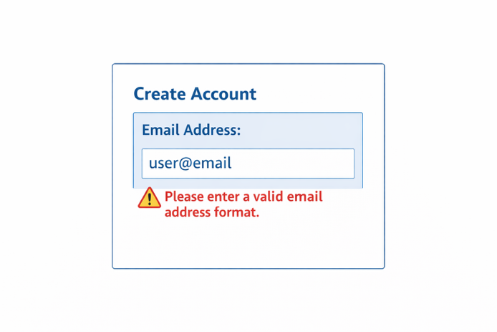
Instead of waiting until the user submits the form and then displaying an error, the system provides immediate feedback. This helps reduce frustration and guides users toward completing the task successfully.

Topic #96: You Can Engineer Better Group Decisions
Another topic I found interesting was #96: You Can Engineer Better Group Decisions. This idea focuses on how groups of people make choices and how those decisions can be improved through structure and process. Many people assume that group decisions are always better than individual ones, but that is not always true. Groups can sometimes suffer from problems like groupthink, where people agree with the majority instead of sharing their own ideas.
Embellish:
One way teams improve group decisions is by collecting ideas from individuals before group discussion begins. This allows everyone to contribute their thoughts independently instead of being influenced by the first person who speaks. Many companies now use collaboration tools that allow team members to vote or comment on ideas before making final decisions. This approach helps ensure that decisions are based on multiple perspectives rather than one dominant voice.
In web design and development teams, this is important because projects often involve designers, developers, and project managers working together. Structured decision processes help teams evaluate ideas more fairly and make better choices about layout, functionality, and user experience.
Visual Example:
Some design teams use feature voting systems when deciding on new website features.
Example interface:

This type of design allows teams to gather feedback quickly and make decisions based on collective input rather than personal opinion.

References:
100 Things Every Designer Needs To Know About People; Susan M. Weinschenk, Ph.D.
Topic 87: Not All Mistakes Are Bad Pg. 196
Topic 96: You Can Engineer Better Group Decisions Pg. 216-217
Comic image; Scott Adams: Dilbert

Also found this image for Topic 96: Relatable. Sometimes we can engineer better decisions.
